INSTRUMENTAL METHODS OF ANALYSIS- BP701T

UNIT : 1 UV Visible spectroscopy
CLASS:4 Beer lamberts law & derivation

TOPIC: BEER LAMBERT’S LAW & DERIVATION
Light absorption of ultraviolet and visible light occurs due to absorption of energy by electrons which can be excited (such as π-electrons). Practically when a beam of light hits a substance, the machine can measure the intensity or power of light before it strikes the substance (I₀), and then after it goes through the substance (I_{t}). The incident light may undergo absorption, reflection, interference, and scattering before it is transmitted. Thus the intensity of light through the substance (I_{t}) will be reduced.
Two laws related to the absorption of radiation are:
1. Beer’s law (related to concentration of absorbing species)
2. Lambert’s law (related to thickness/path length of absorbing species)

Beer’s Law
Beer’s law can be defined as the intensity of a beam of parallel monochromatic radiation decreases exponentially with the increase in concentration of absorbing molecules. More simply, it stated that absorbance is proportional to the concentration (c) of the solution.
Lambert’s Law
Lambert law stated that the rate of decrease in the intensity of light with thickness (b) of the medium is proportional to the intensity of the incident light

Derivation of Beer-Lambert Law
For each wavelength of light passing through the spectrometer, the intensity of the light passing through the reference cell is measured. This is usually referred to as I_{o} .

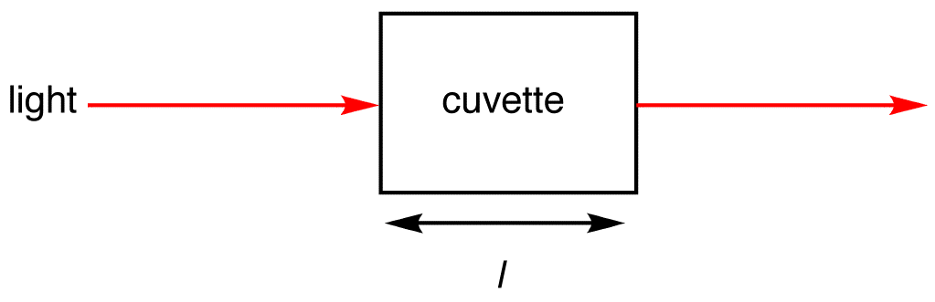
Figure 2.3 Light absorbed by sample in a cuvette
The intensity of the light passing through the sample cell is also measured for that wavelength - given the symbol, I_{t}. If I_{t} is less than Io, then the sample has absorbed some of the light (neglecting reflection of light off the cuvette surface). A simple bit of math is then done in the computer to convert this into something called the absorbance of the sample, given the symbol, A. The absorbance of a transition depends on two external assumptions.
- Absorbance is directly proportional to the concentration (c) of the solution of the sample used in the experiment.

– dI / dc ∝ I —– (1)
Where dI is the slight decrease in light intensity when passing through a solution with concentration of dc, and I is the intensity of monochromatic light just before entering the medium.
– dI / dc = kI —– (2)
Where –dI/dx is the rate of decrease in strength with thickness dx, and a is called the absorption coefficient.
By the integral of Eq. (2) after dislocation,
– ln I = kc + b —– (3)
Where C is the constant of integration. At x = 0, I = Io. Therefore, b= – ln Io. Substituting this into equation (3) yields:
ln I/ Io = – kc — (4)
Equation (4) can also be written as,
I_{t} = Io e−kc — (5)
Equation (5) can also be written as,
log I/ Io = − a/ 2.303 x — (6)
or, log I/ Io = -a’ x — (7)
Where a’ (= a / 2.303) is the extinction coefficient and -ln I / Io is the absorbance of the medium. Absorbance is represented by A.

Lamberts law derivation
Absorbance is directly proportional to the length of the light path (l), which is equal to the width of the cuvette
– dI / dt ∝ I —– (8)
Where dI is the slight decrease in light intensity when passing through a solution with concentration of dc, and I is the intensity of monochromatic light just before entering the medium.
– dI / dt = kI —– (9)
Where –dI/dx is the rate of decrease in strength with thickness dx, and a is called the absorption coefficient.
By the integral of Eq. (9) after dislocation,
– ln I = kt + b —– (10)
Where C is the constant of integration. At x = 0, I = Io. Therefore, b= – ln Io. Substituting this into equation (10) yields:
ln I/ Io = – kt — (11)
Equation (11) can also be written as,
I_{t} = Io e^{−kt} — (12)

On combining 5&12
I_{t} = Io e^{−kct}
It/Io = e^{−kct}
Io/It = e^{kct}
Taking log on both sides
Log Io/It = KCT
Where, Transmittance, T = It/ Io
Absorbance, A=Log Io/It (Log 1/T)
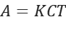
K is called molecular absorption coefficient or molar absorptivity or molar extinction coefficient.

