INSTRUMENTAL METHODS OF ANALYSIS- BP701T

UNIT : 1 UV Visible spectroscopy
CLASS: 3 electronic transitions, definitions & shifts

TOPIC: ELECTRONIC TRANSITIONS

Electronic transitions

The absorption of UV or visible radiation corresponds to the excitation of outer electrons. There are two types of electronic transition which can be considered;
- Transitions involving p, s, and n electrons
- Transitions involving charge-transfer electrons
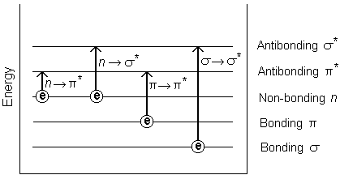
Figure 3.1 Possible electronic transitions of p, s, and n electrons
σ− σ*Transitions
An electron in a bonding orbital is excited to the corresponding antibonding orbital. The energy required is large. For example, methane (which has only C-H bonds, and can only undergo σ− σ* transitions) shows an absorbance maximum at 125 nm. Absorption maxima due to σ− σ* transitions are not seen in typical UV-Vis. spectra (200 - 700 nm)

n - σ* Transitions
Saturated compounds containing atoms with lone pairs (non-bonding electrons) are capable of n-σ* transitions. These transitions usually need less energy than n-σ* transitions. They can be initiated by light whose wavelength is in the range 150 - 250 nm. The number of organic functional groups with n-σ* peaks in the UV region is small.

n-π* and π−π* Transitions
Most absorption spectroscopy of organic compounds is based on transitions of n or π electrons to theπ * excited state. This is because the absorption peaks for these transitions fall in an experimentally convenient region of the spectrum (200 - 700 nm). These transitions need an unsaturated group in the molecule to provide the π electrons.

Charge - Transfer Absorption
Many inorganic species show charge-transfer absorption and are called charge-transfer complexes. For a complex to demonstrate charge-transfer behaviour, one of its components must have electron donating properties and another component must be able to accept electrons. Absorption of radiation then involves the transfer of an electron from the donor to an orbital associated with the acceptor. Molar absorbtivities from charge-transfer absorption are large (greater that 10,000 L mol-1 cm-1).
Chromophore
It is a covalently unsaturated group which is responsible for absorption of UV or visible radiation and may or may not impact in colour to the compound.
A compound which contains chromophore it is called chromogen.
In unsaturated linkage such as -c=c- ,
-N=N-, the π electron are loosely bound. These loosely bound electron required less energy for electronic transition and the absorption band occur in near UV region.
Example Acetylene possessed -C=C- in structure it λmax is 175-180 nm.
Auxo chrome
It is saturated and unsaturated group which consists of one or more pair of non-bonded electron.
This group is attached to Chromophore help in altering the wavelength by increasing the intensity of absorption and increase λmax.
Example of Auxochrome is -OH, -NH2,-OR etc.

Type of Shift
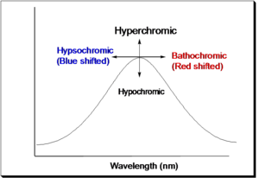
Figure 3.2: Type of shift in lambda max

1. Bathochromic shift ( Red shift ) :-
In this Types the absorption maximum shift towards longer wavelength.
When two or more chromophore present in a molecule is responsible for bathochromic shift.
Ex. Ethene which contain unconjugated double bond show λmax at 170 nm.
2. Hypsochromic shift ( Blue shift) :-
In this Type the absorption maximum shift towards shorter wavelength. This shift is occur due to removal of conjugation or due to change in the polarity of the solvent.
Ex. Aniline show λmax at 280 nm because of on conjugation between lone pair of electron between nitrogen and benzene.
3. Hyperchromic shift :-
In this Type of shift increase intensity with increase of absorption of radiation.
This is due to the introduce Auxochrome.
Ex. Increase intensity of the absorption of DNA due to denaturation at the λmax 260 nm.

4. Hypochromic shift :–
In this Type of shift decrease intensity of radiation because of decreased absorption.
It is due to presence of certain group which may cause deformation of structure of compound.

