INSTRUMENTAL METHODS OF ANALYSIS- BP701T

UNIT : 1 UV Visible spectroscopy
CLASS:10
TOPIC: FACTORS AFFECTING FLUORESCENCE, QUENCHING

FACTORS AFFECTING FLUROSCENSE INTENSITY

- Chemical Structure: - Fluorescence is most commonly observed in most compounds containing aromatic functional groups with low energy. Unsubstituted aromatic hydrocarbons show fluorescence, quantum efficiency increases with the number of rings and degree of condensation. Simple heterocyclic do not exhibit fluorescence. Fusion of heterocyclic nucleus to benzene ring increases fluorescence. Substitution on the benzene ring shifts wavelength of fluorescence absorbance maxima and corresponding changes in fluorescence peaks. Substitution of carboxylic acid or carboxylic group on aromatic ring inhibits fluorescence. Fluorescence decreases with increasing atomic no. of the halogen.

Fluorescence is favored in molecules with structural rigidity. Organic chelating agents complexed with metal ion increases fluorescence.

- Nature of substituent: - All the molecules cannot show phenomenon of fluorescence. Only the molecules absorb UV/visible radiation can show this phenomenon. Greater the absorbency of the molecule the more intense its fluorescence.

- Nature of molecule: - Electron donating group enhances fluorescence (e.g.-NH2, -OH etc.). Electron withdrawing groups decrease or destroy fluorescence. (e.g.: COOH, NO₂, N=N, etc,). Introduction of High atomic number atom into electron system decreases fluorescence.

- Concentration: - Fluorescence is directly proportional to concentration.

FI = Q X I_{a},
Where,

F = QI_{O}act (I_{a=}I_{O}act by Beer-Lamberts law)
Q = Constant for a particular substance
I_{O} = Constant for an instrument
a = Molecular extinction coefficient
t = Path length
C = Concentration of the substance

F = KC,
Where,
K represents all constants

Fluorescense intensity α Concentration.

Extreme sensitiveness of the method requires very dilute solution. Adsorption of the fluorescent substances on the container wall creates serious problems. Hence, strong solutions must be diluted.

- Oxygen:- The presence of oxygen may interfere in 2 ways:-

- By direct oxidation of the fluorescent substances to non fluorescent.
(ii) By quenching of fluorescence.

- pH:- Alteration of the pH of the solution will have significant effect on fluorescence Fluorescent spectrum is different for ionized and un-ionized species.

- Temperature & Viscosity:- Increase in temperature/decrease in viscosity will decrease fluorescence.

QUENCHING OF FLORESCENCE AND TYPES

Quenching is the decrease in florescence intensity due to specific effects of constituents of the solution itself. The effect may be due to various factors like concentration, pH, presence of specific substances, temperature, viscosity, etc. Types of quenching are Self / Concentration quenching, Collision quenching, Static quenching and Chemical quenching.

- Self Quenching/ Concentration quenching:- Concentration quenching is a kind of self quenching. It occurs when the concentration of the fluorescing molecule increases in a sample solution. The fluorescence intensity is reduced in highly concentrated solution ( >200 μg/ml ).

- Collisional quenching: - Collisional quenching occurs by the interaction of a quencher molecule (Q) with an excited molecule of the fluorescing substance (F*). Collisional quenching is due to Halides ions such as chlorides or, iodides are well known collisional quenchers. For example, quenching of quinine drug by chloride ion or quenching of tryptophan by iodide ion follow collisional quenching process.

- Static quenching: - This occurs due to complex formation. e.g. caffeine reduces the fluorescence of riboflavin by complex formation.

- Chemical quenching: - Chemical quenching is due to various factors like change in pH, presence of oxygen, halides and electron withdrawing groups, heavy metals etc.

INSTRUMENTATION

All fluorescence instruments contain following basic items:-
- a source of light,
- filters/monochromators,
- a sample holder and
- a detector.
(a) Source of light:-
(i) Mercury vapour lamp: - Mecury vapour at high pressure give intense lines on continuous background above 4200nm. Low pressure mercury vapour gives an additional line at 2204nm. It is used in filter fluorimeter.

(ii) Xenon arc lamp: - It give more intense radiation than mercury vapour lamp. It is used in spectrofluorimeter.

(iii) Tungsten lamp: - If excitation has to be done in visible region this can be used. It is used in low cost instruments.
(b) Filters and Monochromators:-
(i) Filters: - These are nothing but optical filters works on the principle of absorption of unwanted light and transmitting the required wavelength of light. In inexpensive instruments fluorimeter primary filter and secondary filter are present. Primary filter absorbs visible radiation and transmit UV radiation. Secondary filter absorbs UV radiation and transmit visible radiation.

(ii) Monochromator: - They convert polychromatic light into monochromatic light. They can isolate a specific range of wavelength or a particular wavelength of radiation from a source. Excitation monochromators provides suitable radiation for excitation of molecule. Emission monochromators isolate only the radiation emitted by the fluorescent molecules.

(c) Sample cells: - These are meant for holding liquid samples. These are made up of quartz and can have various shapes ex: cylindrical or rectangular etc. The cells are made up of coloured corrected fused glass and path length is normally 10mm or 1cm.It need not be made up of quartz glass, since we are measuring emitted radiation only and all the surfaces are polished in flourimetry because emission measurements are made at 90⁰ angle.

(d) Detectors: - Barrier layer cell/ Photo voltaic cells, Photomultiplier cells.

(i) Barrier layer /photovoltaic cell: - It is employed in inexpensive instruments. For ex: Filter Fluorimeter. It consists of a copper plate coated with a thin layer of cuprous oxide (Cu₂o). A semi transparent film of silver is laid on this plate to provide good contact. When external light falls on the oxide layer, the electrons emitted from the oxide layer move into the copper plate. Then oxide layer becomes positive and copper plate becomes negative. Hence, an EMF develops between the oxide layer and copper plate behaves like a voltaic cell. So it is called photovoltaic cell. Galvanometer is connected externally between silver film and copper plate and the deflection in the galvanometer shows the current flow through it. The amount of current is found to be proportional to the intensity of incident light.

(ii) Photomultiplier tubes: - These are incorporated in expensive instruments like spectrofluorimeter. Its sensitivity is high due to measuring weak intensity of light. The principle employed in this detector is that, multiplication of photoelectrons by secondary emission of electrons. This is achieved by using a photo cathode and a series of anodes (Dyanodes). Up to 10 dyanodes are used. Each dyanode is maintained at 720- 100Vhigher than the preceding one. At each stage, the electron emission is multiplied by a factor of 4 to 20 due to secondary emission of electrons and hence an overall factor of 106 is achieved. Photomultiplier tubes can detect very weak signals, even 200 times weaker than that could be done using photovoltaic cell. Hence it is useful in fluorescence measurements. Photomultiplier tubes should be shielded from stray light in order to have accurate results.
Instruments: The most common types are:-
- Single beam (filter) fluorimeter
- Double beam (filter) fluorimeter
- Spectrofluorimeter (double beam)
Single beam instruments:- It contains tungsten lamp as a source of light and has an optical system consists of primary filter. The emitted radiation is measured at 90⁰ by using a secondary filter and detector. Primary filter absorbs visible radiation and transmit uv radiation which excites molecule present in sample cell. Instead of 90º if we use
180ºgeometry as in colorimeter secondary filter has to be highly efficient otherwise both the unabsorbed uv radiation and fluorescent radiation will produce detector response and give false result. Single beam instruments are simple in construction, cheaper and easy to operate.

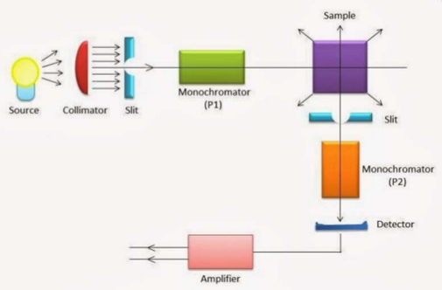
Figure 11.1: Single beam flourimeter
Double beam instruments: It is similar to single beam except that the two incident beams from a single light source pass through primary filters separately and fall on the another reference solution. Then the emitted radiations from the sample or reference sample pass separately through secondary filter and produce response combinely on a detector.
Spectrofluorimeter:- In this primary filter in double beam fluorimeter is replaced by excitation monochromator and secondary filter is replaced by emission monochromator. The Incident beam is split into sample and reference beam by using beam splitter.

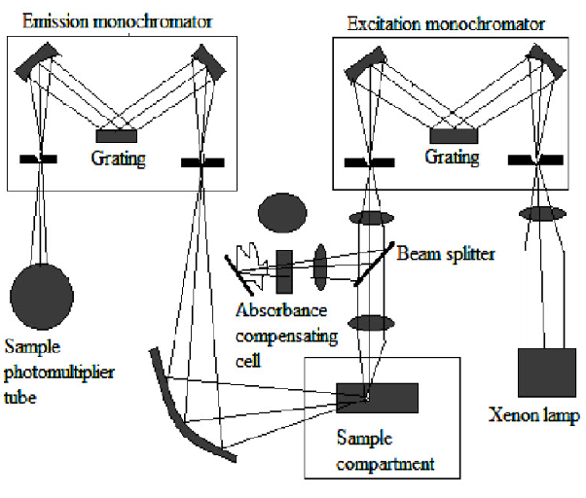
Figure:11.2 Double beam - spectrofluorimeter

APPLICATIONS

1. Determination of inorganic substances viz., Al⁴⁺, Li⁺ and Zn²⁺
2. Determination of thiamine HCl.
3. Determination of phenytoin.
4. Determination of indoles, phenols & phenothiazines
5. Determination of napthols, proteins, plant pigments and steroids.
6. Determination of ruthenium ions in presence of other platinum metals.
7. Determination of boron in steel, aluminum in alloys, manganese in steel.
8. Determination of boron in steel by complex formed with benzoin.

Fluorimetry, nowadays can be used in detection of impurities in nanogram level better than absorbance spectrophotometer with special emphasis in determining components of sample at the end of chromatographic or capillary column.

