INSTRUMENTAL METHODS OF ANALYSIS- BP701T

UNIT : 1 UV Visible spectroscopy
CLASS:2 Colorimeter, electronic transitions

TOPIC: COLORIMETER, ELECTRONIC TRANSITIONS
Colorimeter

Colorimetry is one of the methods of spectroanalytical methods. The variation of the colour of a solution with a change in concentration of some solute component in the solution forms the basis of colorimetry.
The colour is either the inherent colour of the constituent itself or due to the formation of a coloured species by the addition of a suitable reagent. The intensity of the colour can then be compared with that obtained by treating a known amount of the chemical substance in the same manner.

General Principles of Colorimeter
A colorimeter may be used to measure the concentration of a chemical in a solution if the chemical imparts a characteristic colour to the solution.
- The colorimeter optical system isolates a narrow waveband of light at a selected absorption peak for the chemical that is measured.
- The intensity of the transmitted light at the absorption wavelength is a function of the concentration of the chemical in the solution.
- When only the light at this wavelength is used, Beer’s law is obeyed and maximum sensitivity is obtained for the instrument.
- The use of the narrow wavelength band usually makes possible the elimination of the absorption effects of other chemicals in the solution.
- However, the effect of some chemicals cannot be eliminated if they change the complex ion formation of the chemical being measured. This is the case when uranyl nitrate is measured in a solution containing nitric acid.
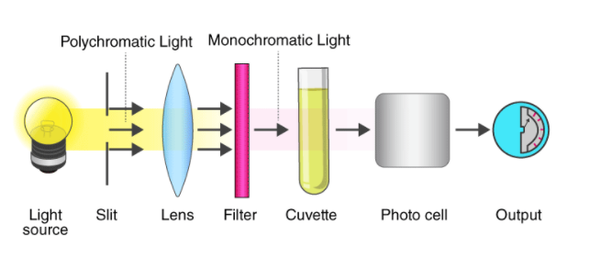
A more stable colorimeter can be made if the dual beam principle is utilized. This is usually accomplished by comparing the light intensity at an absorption wavelength with the intensity of a reference beam from the same light source.
Uses of Colorimeter
A colorimeter uses the human eye as the detector. The user compares the observed colour of the unknown sample against a standard or a series of coloured standards of known concentrations.
- Colorimeter is a small and portable device that can be used to analyze the colour contrast and the brightness on a television or computer screen, allowing the user to adjust the settings to obtain the best quality picture.

UV-Visible spectroscopy
Ultraviolet–visible spectroscopy or ultraviolet-visible spectrophotometry (UV-Vis or UV/Vis) refers to absorption spectroscopy or reflectance spectroscopy in the ultraviolet-visible spectral region. This means it uses light in the visible and adjacent ranges.
PRINCIPLE
Ultraviolet and visible (UV-Vis) absorption spectroscopy is the measurement of the absorption of a beam of light whose wavelength ranges from 200nm -800nm after it passes through a sample Absorption measurements can be at a single wavelength or over an extended spectral range.
Ultraviolet absorption spectra arise from transition of electron with in a molecule from a lower level to a higher level. A molecule absorb ultraviolet radiation of frequency (ν), the electron in that molecule undergo transition from lower (Eₒ) to higher energy level (E₁ ).
The energy can be calculated by the equation,
E=hν,
E₁-Eₒ= hν,
E_{total}=E_{electronic}+E_{vibrotional}+E_{rotational}
The energies decreases in the following order: Electronic >Vibrational>Rotational
When a sample is exposed to light energy that matches the energy difference between possible electronic transitions within the molecule, a fraction of the light energy would be absorbed by the molecule and the electrons would be promoted to the higher energy state orbital. A spectrometer records the degree of absorption by a sample at different wavelengths and the resulting plot of absorbance (A) versus wavelength (λ) is known as a spectrum.

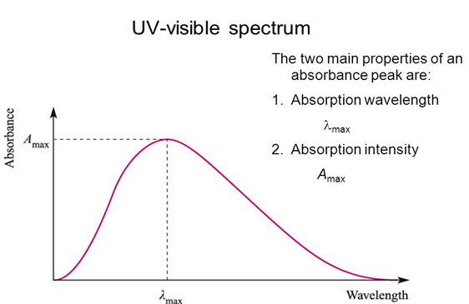
Figure 2.1 UV-Visible Spectrum
λ_{max} is the wavelength at which there is a maximum absorption of radiation takes place.
The λ_{max} is characteristic or unique for every coloured substance and this is a qualitative aspect, useful in identifying the substance. λ_{max} is not usually affected by concentration of the solution. A_{max} is the intensity of maximum absorption.
The interaction with the shorter wavelength, higher energy radiation in the UV (200-400 nm) and visible (400-700 nm) range of the electromagnetic spectrum causes many organic molecules to undergo electronic transition
Electronic transitions

The absorption of UV or visible radiation corresponds to the excitation of outer electrons. There are two types of electronic transition which can be considered;
- Transitions involving p, s, and n electrons
- Transitions involving charge-transfer electrons
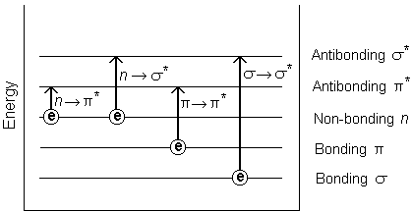
Figure 2.2. Possible electronic transitions of p, s, and n electrons

