INSTRUMENTAL METHODS OF ANALYSIS- BP701T

UNIT : 1 UV Visible spectroscopy
CLASS:1 Introduction, EMR

TOPIC: INTRODUCTION TO ELECTROMAGNETIC SPECTRUM

INTRODUCTION
Spectroscopy is the study of the interaction between matter and electromagnetic radiation. Spectroscopy relies on beams of light, which is a form of radiation. The structure of atoms and molecules comes from studying their interaction with light (electromagnetic radiation). Different regions of the electromagnetic spectrum provide different kinds of information as a result of such interactions.
Electromagnetic radiation is a form of energy that is produced by oscillating electric and magnetic disturbance, or by the movement of electrically charged particles traveling through a vacuum or matter. Electron radiation is released as photons, which are bundles of light energy that travel at the speed of light as quantized harmonic waves. This energy is then grouped into categories based on its wavelength into the electromagnetic spectrum. These electric and magnetic waves travel perpendicular to each other and have certain characteristics, including amplitude, wavelength, and frequency.
General Properties of all electromagnetic radiation:
- Electromagnetic radiation can travel through empty space. Most other types of waves must travel through some sort of substance. For example, sound waves need either a gas, solid, or liquid to pass through in order to be heard.
- The speed of light is always a constant. (Speed of light : 2.99792458 x 10⁸ m s⁻¹)
- Wavelengths are measured between the distances of either crests or troughs. It is usually characterized by the Greek symbol λ.
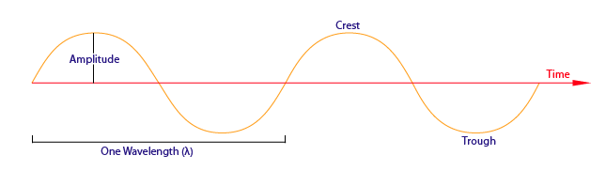
Figure 1.1 General representation of wave
Amplitude:
Amplitude is the distance from the maximum vertical displacement of the wave to the middle of the wave. This measures the magnitude of oscillation of a particular wave. In short, the amplitude is basically the height of the wave. Larger amplitude means higher energy and lower amplitude means lower energy. Amplitude is important because it tells you the intensity or brightness of a wave in comparison with other waves.

Wavelength:

Wavelength (λ) is the distance of one full cycle of the oscillation. Longer wavelength waves such as radio waves carry low energy; this is why we can listen to the radio without any harmful consequences. Shorter wavelength waves such as x-rays carry higher energy that can be hazardous to our health. This wavelength frequently relationship is characterized by:

c=λν
where
- c is the speed of light,
- λ is wavelength, and
- ν is frequency.
Shorter wavelength means greater frequency, and greater frequency means higher energy. Wavelengths are important in that they tell one what type of wave one is dealing with

Frequency:
Frequency is defined as the number of cycles per second, and is expressed as sec⁻¹ or Hertz (Hz). Frequency is directly proportional to energy and can be express as:
E=hν
E=hν
where
- E is energy,
- h is Planck's constant, (h= 6.62607 x 10⁻³⁴ J), and
- ν is frequency.

1.3 THE ELECTRO MAGNETIC SPECTRUM
EM radiation spans an enormous range of wavelengths and frequencies. This range is known as the electromagnetic spectrum. The EM spectrum is generally divided into seven regions, in order of decreasing wavelength and increasing energy and frequency. The common designations are: radio waves, microwaves, infrared (IR), visible light, ultraviolet (UV), X-rays and gamma rays. Typically, lower-energy radiation, such as radio waves, is expressed as frequency; microwaves, infrared, visible and UV light are usually expressed as wavelength; and higher-energy radiation, such as X-rays and gamma rays, is expressed in terms of energy per photon.

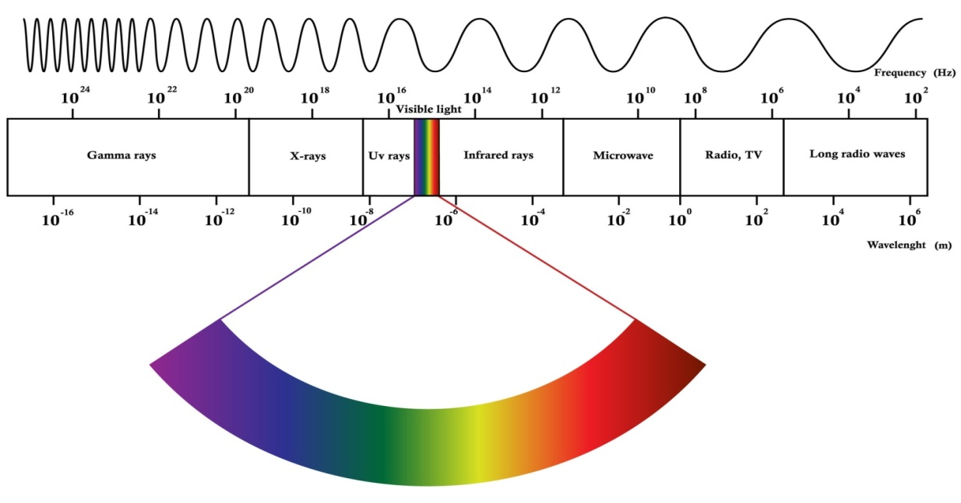
Figure 1.2 Electromagnetic spectrum

1.4 DIFFERENT TYPES OF SPECTROSCOPY:
A. Based on the level of study. Here the classification is done based on the study made at atomic or molecular level. When light is allowed to pass through the substance, changes in atomic level or molecular level is observed.

1. Atomic spectroscopy: Here energy changes takes place at atomic levels. The measurement is done to study the atoms and their quantity. This is of two types as atomic absorption spectroscopy and atomic emission spectroscopy. These are referred as atomic absorption spectroscopy and flame photometry respectively.
Here the sample mostly metals and their formulations are converted to atomic forms and then measured. Ex: Sodium, calcium, magnesium related formulations.
2. Molecular spectroscopy: Here the energy changes occurring at the level of molecule are studied. The characters like molecular absorption. emission and vibration are studied.
The examples include, colorimetry, UV-spectroscopy, infra red, FTIR, fluorimetry etc.
This method of spectroscopy is widely used due to many applications. The methods are quick, easy and accurate in determination. Further they are easily integrated into other analytical techniques like chromatography.

B. Based on the property of either absorption or emission.
Here the principle of abortion or emission of electromagnetic radiation is taken into consideration.

1. Absorption spectroscopy: In this spectroscopy there is absorption of light by the sample. The extent of absorption and the wavelength of the absorbed light is considered. The wavelength of light absorbed tells the nature of the compound while the intensity of absorbed light tells the concentration.
The examples of the spectroscopic methods coming under this method are colorimetry, UV-spectroscopy, infra red spectroscopy, Nuclear magnetic resonance (NMR), atomic absorption spectroscopy.

.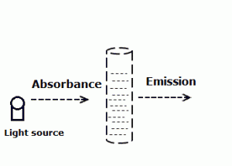

Figure 1.3 Absorption of light by sample

2. Emission spectroscopy: Contrary to the above method, here the emitted light is measured. Once the light impinges on the sample, some of it is absorbed. This absorption of light leads to transition of electrons from ground state to excited state. These excited electrons return back to ground state by release of electromagnetic radiation (light) of specific wavelength. The intensity gives the concentration while the wavelength tells the nature of the compound.
Examples include fluorimetry, flame photometry.
C. Based on the level of study i.e. electronic or magnetic levels.
Here the study is done based on electronic or magnetic properties of the compound. Light is an electromagnetic radiation. That is it has both electronic and magnetic properties.
1. Electronic spectroscopy: So when a compound is estimated without the magnetic field we call it electronic spectroscopy. In this method the substance under test is exposed to light without the influence of magnetic field.
Examples of this method are again colorimetry, UV-spectroscopy, IR, fluorimetry etc.

2. Magnetic spectroscopy: Here the substance is exposed to electromagnetic radiation in presence of external magnetic field.
Examples include Nuclear magnetic resonance spectroscopy (NMR), Electron spin resonance spectroscopy (ESR).

